***Themed activities***

December will be packed with festive fun as we begin to prepare for Christmas!

We are planning lots of explosively sparkly crafty fun with all the children, lots of festive stories & a parent/carer craft day with your little one (please see “Important dates” for further information)



#TeamBrookside would like to wish you all a very, merry Christmas!

We look forward to welcoming you all back on **Wednesday 5th January 2022** for another year of fun!

**Christmas Fayre –** Come along & join us for a fun filled afternoon, among others, we will be having a raffle, guess how many sweets, guess the name of the soft toy, toy sale and more!

**Christmas Craft Morning** - Open to ALL pre-school children, this is a fun morning set up for both parent/carer & child to come along & have some creative festive fun together!

**Christmas Disco/Buffet** - Lets end the term with an afternoon of party fun! Open to ALL pre-school children, drop your little one off in their festive wear to have an afternoon of dancing with some party nibbles!

***Important dates December***

**Week Commencing Monday 13th** Christmas Jumper week

**Monday 13th** 13.30-15.30 Christmas fayre. *There will be NO afternoon sessions, all children from morning session will need to be collected by 12pm.*

**Tuesday 14th** Trip to Colchester Zoo. *Preschool will be closed for the whole day*

**Friday 17th** (No session all day) 9am - 11am Christmas Craft morning 13.00 - 15.00 Christmas Disco & Buffet

All lost sessions will be offered in lieu – Please speak to a member of staff to arrange this

**www.brooksideip2.org**

**December 2021**

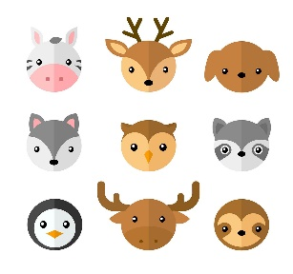

***Staff Changes***

We would like to welcome back**Kelly** who has returned from maternity leave

We also say goodbye to **Rebecca** who has decided to leave Brookside

**December 2021**

*Welcome to our* ***December*** *edition of our monthly newsletter where you can find out all the information about our plans, activities & trips for the month ahead*

***Lost property***

We still have a large quantity of lost property to be reunited with their owners, these are found outside our main gate in a blue crate. Any items remaining for our next school holiday, will be disposed of

A big **THANK YOU** to all the children who took part in our pyjama day, for the cake donations or for buying some to help raise some money for Children in Need 2021.

Altogether we raised an amazing **£48.51**!

A huge **THANK YOU** from #TeamBrookside

Some of the children’s creations they made during November …



**Donations Required**

We are looking for donations of new items that can be used in our Chrsitmas Raffle, these can be toiletries, sweets, chocolates & so forth