




May Half Term Holiday Club
This Photo by Unknown Author is licensed under CC BY-NC

Tuesday 30th May  Park & Picnic   | Wednesday 31st May  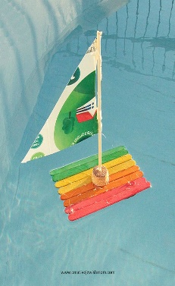  Making and racing boats | Thursday 1st June  Suffolk Show  (Limited numbers & additional charge)  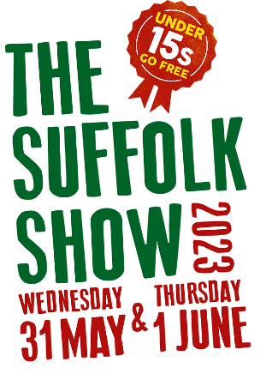 | Friday 2nd June  Creative messy day!  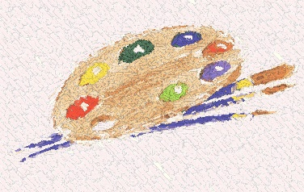

May Half Term Booking form
This Photo by Unknown Author is licensed under CC BY-NC

NEW TIMES AND PRICES
Breakfast from 8.30 till 8.50 (free)
Day Price - £27.50 (dinner optional)
8.30am to 6.00pm
Childs Name ____________
Any Trip days please book in all day
Please bring a packed lunch
Date | Times | Dinner
Tuesday 30th May
Wednesday 31st May
Thursday 1st June
(Additional charge £12.50 & limited numbers)
Friday 2nd June

Children are allowed to bring electronic devices as long as they do not use the camera and they do so at their own risk, Brookside will not be held responsible for any damages.

